RECRUITING TIMELINE 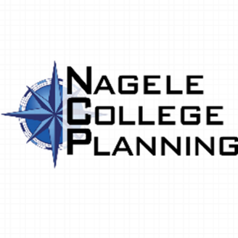

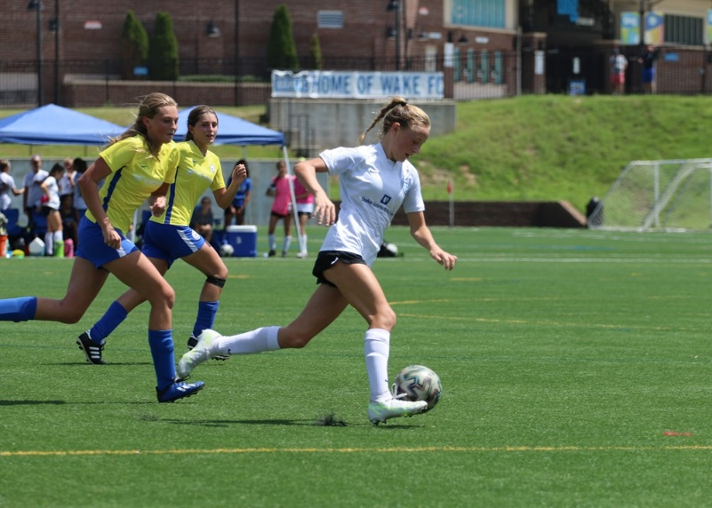
Recruiting Timeline:
To maximize your chances of getting recruited to play in college, check out our in-depth college recruiting resources. While the process should be driven by the individual athlete, Nagele College staff and directors are here to provide you with the support and assistance you need to reach your goals. See our college recruiting timeline below for a breakdown of the process throughout your high school years.
Additionally, if you want to compete in NCAA sports at a Division I, II or III school, you need to register with the NCAA Eligibility Center to make sure you stay on track to meet initial-eligibility standards.
Check our Eligibility page for more information

First Year (9th Grade) -
• Meet with College Placement Director in order to create individual recruiting plan.
• Participate in College Recruiting Night and the Online Seminars.
• Become familiar with the NCAA DI, DII, DIII, NAIA and JUCO academic requirements
• Meet with your high school guidance counselor to set up a four-year academic plan
• Start an academic path that will satisfy NCAA Rules and Guidelines
Set short and long-term academic goals with your family
Set short and long-term soccer goals with your family and/or coach
Understand your academic path to schedule AP classes for junior and senior years
• Participate in community service and school activities (student government, math club, etc.)
• Attend local college games at any division to better understand level and atmosphere
• Strive for good grades to start your high school academic year
• Create a College Fit Finder profile
• Make a list of 15-25 college that you may be interested in attending.
• Meet and review your goals and school list with team Head Coach and College Placement Director
• Create your free NCAA Profile
• Create an athletic plan – where am I trying to go in four years – NCAA Division, Pro Path, etc.
• Attend College ID Camps
• Get involved in extra curricular activities both at your school and the community - (student government, community service, clubs etc...)
• Start creating a player profile with athletic and academic accomplishments.
• Start attending showcase events with team.
• Become the best player you can be – what does that mean to you? How important is soccer in my life?

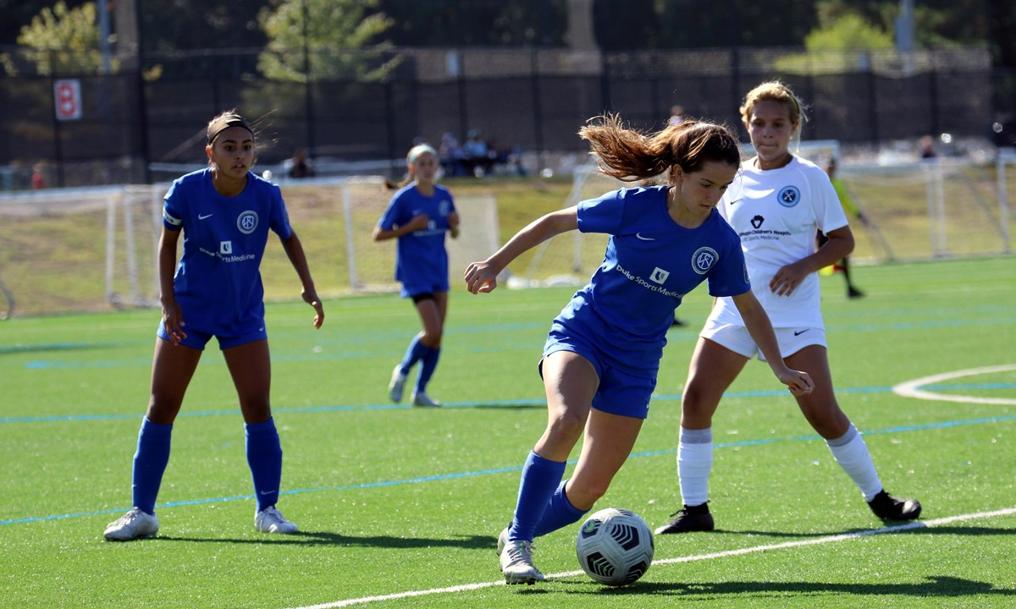
Sophomore (10th Grade) -
• Meet with College Placement Director in order to enhance individual recruiting plan.
• Participate in College Recruiting Night and the Online Seminars.
• Make sure your class schedule satisfies the NCAA core course requirements
• Review your grades and academic goals with your family
• Understand the path to schedule AP classes for junior and senior years
• You will get several inquiries about camps from schools that may appear like recruiting letters – this does not necessarily mean interest.
• Soccer research: look at the past two years' recruiting classes for those schools and current players in your position
• Go watch your schools of interest play games
• Update your College Fit Finder profile
• Review academic plan with your high school counselor.
• Meet and review your goals and school list with team Head Coach and College Placement Director
• Continue to focus on academic and regularly review your progress – self reflection in addition to parental and club involvement.
-Make sure you Create your free NCAA Profile if you have not yet completed that process.
• Make sure you Create your NCAA Certification Account ($80 US/$125 International Students)
Identify 15+ schools of interest and categorize schools on:
• > 5-10 Dream schools (schools you want to or think you can play at)
• > 5-10 Safety schools (schools on your radar but not a dream school)
• > 5-10 Other schools (schools you have little or no information about)

Research the schools on your interest list in the following areas:
• > Academically - Major and Degree
• > Athletically - Level
• > Geographically - Location of school and surrounding areas)
• > Socially – Student population, rural area, etc
• > Financially - Financial aid concerns
Correspond with college coaches via email with your cover letter, resume, academic achievements, highlight video and your team’s upcoming tournament/showcase plans
• If you are playing near a school that you are interested in, email them:
• > a few weeks out
• > the week of the game or event
• > a few days before the game or event
Attend showcase events with team. - Before participating at tournaments and showcases, email all of your schools. (This should be done all the way up until you commit)
• Ensure contact information is correct and updated on your player profile.
• Attend College ID camps and University ID camps of schools you may be interested in.
• Take PSAT (Post COVID standardized testing is becoming less common, but still a factor in a good percentage of college admissions)
• Update your player profile form listing all athletic and academic accomplishments
• Possibly visit college campuses and attend matches to learn about school and soccer programs. We will attempt to arrange some college tours on certain team trips (showcases, tournaments, etc.)
• Focus on your grades – the better the grades the more options you will have. (Coaches love high academic performers in order to stack academic and athletic scholarships)
• Become the best player you can be – what does that mean to you? How important is soccer in my life?

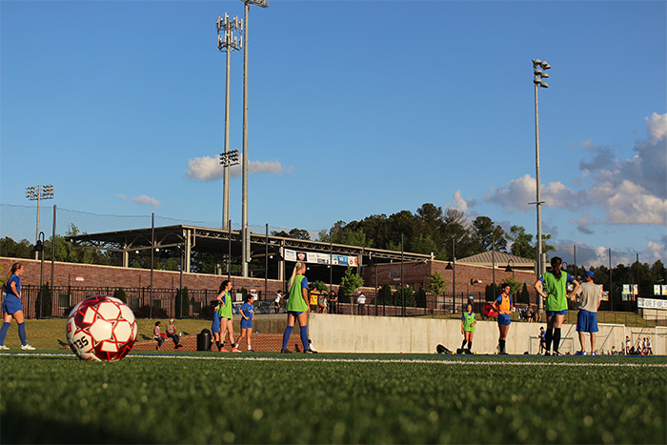
Junior (11th Grade) -
• Meet with College Placement Director in order to review individual recruiting plan – are we looking at the right levels for our playing ability?
• Make sure you are on track with all NCAA core course requirements - Have your counselor send your transcript to the NCAA Eligibility Center
• Meet and review your goals and school list with team Head Coach and College Placement Director
• Participate in College Recruiting Night and the Online Seminars.
- You must be registered with NCAA Eligibility Center (Create your free NCAA Profile & Create your NCAA Certification Account ($80 US/$125 International Students)
- If you are looking at NAIA teams, you must register with the NAIA Eligibility center (http://www.playnaia.org)
• Attend the College ID Camps and ID camps of the universities that are showing actual interest.
• Take the SAT and ACT http://www.collegeboard.com
• You may receive direct contact from college coaches on June 15th prior to entering your junior year
• If possible, take AP and Honors classes
• Narrow your college list to approximately 10-15 schools
• Understand each school's admittance requirements (ACT/SAT, GPA, etc...)
• Review college applications for admittance with family and guidance counselor
•

Official Visits – college coaches will initiate and can pay for all or some of the visit cost.
• > Schedule official visits with schools that have expressed interest
• > If possible, visit during the season when the school plays a home match
• > Try and visit during the week when class is in session to get a good feel of what the campus looks like during class time.
*Update* the college coaches on your soccer and academic achievements and tournament/showcases your team will be attending
• Reply to all emails/phone calls from college coaches, keep lines of communication open
• If you don't have an interest in a particular school, politely let the coach know – Do not ghost them!
• Continue to participate in showcase events with your team
• Attend ID camps for the schools still on your list
• Demand excellence in the classroom
• GPA and Class Rank potentially play a role in admissions and financial aid
• Update your College Fit Finder profile
• Get letters of recommendation – some universities require this for admissions, so be prepared.
• Update your profile as needed – make sure club coach and College Placement Director know of your commitment if you have made one – must be listed on profile.
• Continue to visit colleges of interest and watch matches to find climate and size you prefer
- Fill out the Free Application for Federal Student Aid (FAFSA) http://www.fafsa.ed.gov (can’t be submitted until Jan of the year you will attend and needs to be submitted every year you attend)
- Take AP classes or Honor classes – these classes will help with college admission.
• Make a top 10 preferred college list – who has shown interest? – no point to focus on teams that do not want you if you want to play in college.
• Attend showcase events with team.
• Review all offers with your College Placement Director, Club Coach and Parents.
• Commit to the school of your choice, if you are ready.
• Continue to focus on grades even if you are committed – TO BE THE BEST YOU HAVE TO BEAT THE BEST!
• Continue to play at a high standard – don’t skip out on showcases or games because you are committed - this is a bad look for college coaches and lets the rest of your teammates down.
• Become the best player you can be – Should I be training year around? I am doing enough to be ready for college? 24 Hour Athlete Mentality

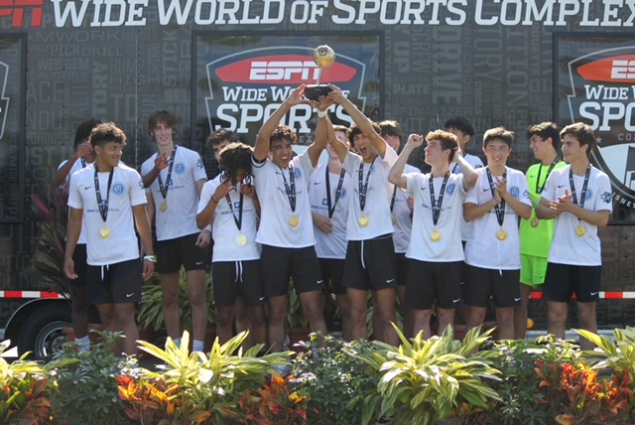
Senior (12th Grade) -
• Meet with College Placement Director in order to finalize individual recruiting plan – are we set and committed for college?
• Make sure you are on track with all NCAA core course requirements - Have your counselor send your transcript to the NCAA Eligibility Center
• Meet and review your goals and school list with team Head Coach and College Placement Director
• Participate in College Recruiting Night and the Online Seminars.
• Narrow your school list to approximately five schools if you are not yet committed.
• *Finalize* any applications
• Complete applications in the fall of senior year
• Allow time to edit and finalize essays and collect letters of recommendations
• Recommended that your teacher or parents review the essays for proofing
• Meet all application/scholarship/financial aid/housing deadlines
• Submit your FAFSA application
• Meet with high school counselor to review and revise your academic plan
• Make sure your class schedule satisfies the NCAA core course requirements
• Send official high school transcripts to NCAA Eligibility Center (mid-year and final) and to schools that received applications
• Official Visits – college coaches will initiate and can pay for all or some of the visit cost.
• > Schedule official visits with schools that have expressed interest
• > If possible, visit during the season when the school plays a home match
• > Try and visit during the week when class is in session to get a good feel of what the campus looks like during class time.
Check in with College Recruiting Coordinator/Director
• Update your College Fit Finder profile
• Follow up on all emails, letters, texts messages and phone calls from college coaches
• Take SAT or ACT again if needed
• Meet with your Coach/Director to discuss your final list of schools
• Sign NLI (National Letter of Intent)
• Apply to the Colleges/Universities of choice (September, October, November) – some have priority deadlines for academic scholarships – make sure you know these dates.
• Prepare, solicit and edit application essay topics & recommendation letters if needed for admissions.
• Submit FAFSA application after January 1st.
• Send mid-year and final transcripts to NCAA or NAIA eligibility center
• Meet with College Placement Director and club coach for assistance as needed
• Follow-up and maintain communication with college coaches – keep them in the loop of your game schedule, awards and any injuries.
• Continue to play with team, attend all sessions, games and showcases – this is what is expected by your teammates, club and college coaches.

